**ASSIGNMENT – 1**

**Simple linear Regression**

**INTERPRETATION:**

**1. Variables:**

* **Dependent Variable**: Profit
* **Independent Variable**: R&D Spend

**2. R² Score: 0.927**

* **Interpretation**: R² value of 92.7% indicates that the model fits the data well. It shows that 92.7% of the variability in profit can be attributed to changes in R&D spending.

**3. Regression Equation:**

* **Intercept**: 49336.668
* **Coefficient**: 0.854  
  The regression equation is:  
  **Profit = 49336.668 + 0.854 × (R&D Spend)**
* **Interpretation**: This equation suggests that an increase in R&D spending leads to a corresponding rise in profit by 0.854 for every unit increase in R&D expenditure.

**4. Scatter plot:**

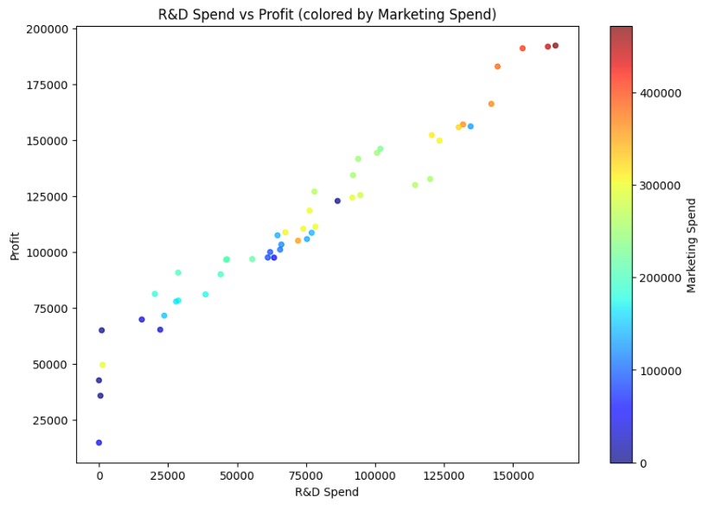

**Interpretation**: The upward linear trend between Profit and R&D Spend suggests that companies that prioritize R&D are likely to see significant financial returns. This relationship highlights the importance of innovation in driving business success and profitability.

**Multiple linear Regression**

**INTERPRETATION:**

1. **Variables:**
   * Dependent Variable: Profit
   * Independent Variables: R&D Spend, Administration, Marketing Spend
2. **R-Squared Value:**
   * The R-Squared value is 0.900, indicating that the model explains 90% of the variability in Profit. This suggests that the model is a strong fit, as a significant portion of the changes in Profit can be attributed to variations in R&D Spend, Administration, and Marketing Spend.
3. **Mean Squared Error (MSE):**
   * The MSE is 80,926,321.223, which is relatively high, indicating a notable deviation from the actual profit figures.
4. **Regression Equation:**
   * Intercept: 54,071.876

Profit = 54,071.876 + 0.804 * (R&D Spend) - 0.068 * (Administration) + 0.031 * (Marketing Spend)

This equation reveals that:

* + An increase in R&D Spend is associated with a profit increase of approximately 0.804.
  + Conversely, an increase in Administration costs leads to a decrease in profit by about 0.068.
  + Similarly, an increase in Marketing Spend results in a profit decrease of roughly 0.031.